**Classification Assignment Report**

* **Identify your problem statement:**

Classification assignment report.

* **Tell basic info about the dataset**

Rows: 399

Columns:28

Output variable: Classification

* **Mention the pre-processing method if you’re doing any (like converting string to number – nominal data)**

Pre-processing method is Nominal data (one hot encoding) because input contains text, we are using get_dummies method and the parameters we are passing dataset, dtype=int, drop_first=true

* **All the research values of each algorithm should be documented. (You can make tabulation or screenshot of the results.)**

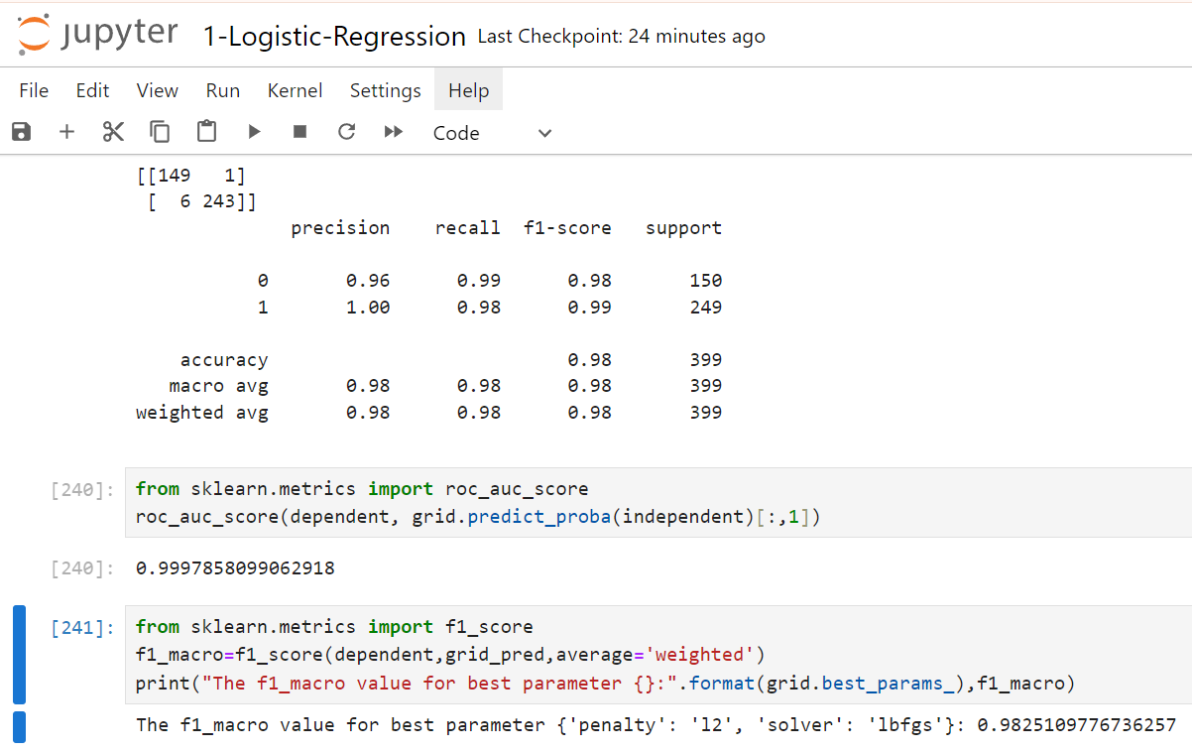

* **Mention your final model, justify why u have chosen the same**

Final model is logistic-regression because the “roc_auc_score” 0.99978580999062918, and accuracy is 98%

**Complete report for all algorithms:**



